## **Assisted Service Module (ASM)**

## **Introduction**

## What is ASM and how it works?

The hybris Assisted Service Module (ASM) enables ASM employees to provide real-time customer sales support, which is using the same website storefront across the Omni-channel framework their customer uses, both **physically in-store**, and **virtually online**.

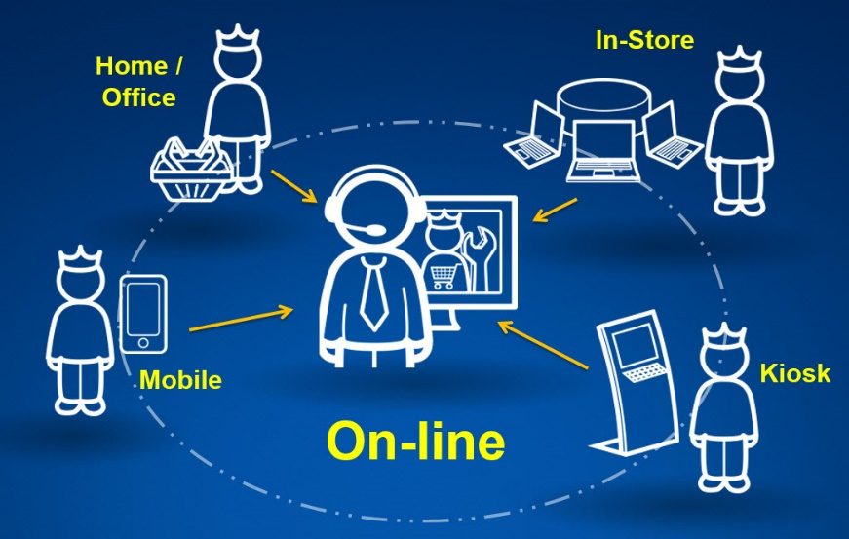

**Challenges:**

1. As companies move traditional offline sales and service models online, they need to consider how it affects their customers’ buying journey.
2. Companies which offer’s complex products and Services run the risk of losing customers in an entirely digital environment.
3. A user may put up to 90% of their effort into the purchase journey on the storefront, without being able to finish their transaction due to product uncertainty or technical difficulties.
4. Those companies that are able to provide effective guided selling to their customers will benefit from reduced costs and increased revenue by limiting such cart abandonment.

**Solution**

1. The ASM allows a customer to finish the remainder of their user journey, by pairing them with customer sales and service support personnel in real-time using the same storefront, with little additional effort.
2. **For example,** when a customer gets stuck with making a purchase or administering their account, they contact customer sales and service support personnel and give them their **cart ID number or account name,** the customer sales and service support person then uses the ASM to find and emulate the customer's cart or account, that then allows them to provide sales, or account administration support.
3. Once the support person has some simple information (eg. cart ID number or account name), they can find and emulate the customer’s cart, allowing them to provide sales or account administration support.
4. Additionally a website storefront can have additional business rules configured to grant the customer sales and service support personnel **special access rights** to display special pricing, promotions, upgrades, entitlements, etc.
5. Below is the picture which explores what exactly ASM do.

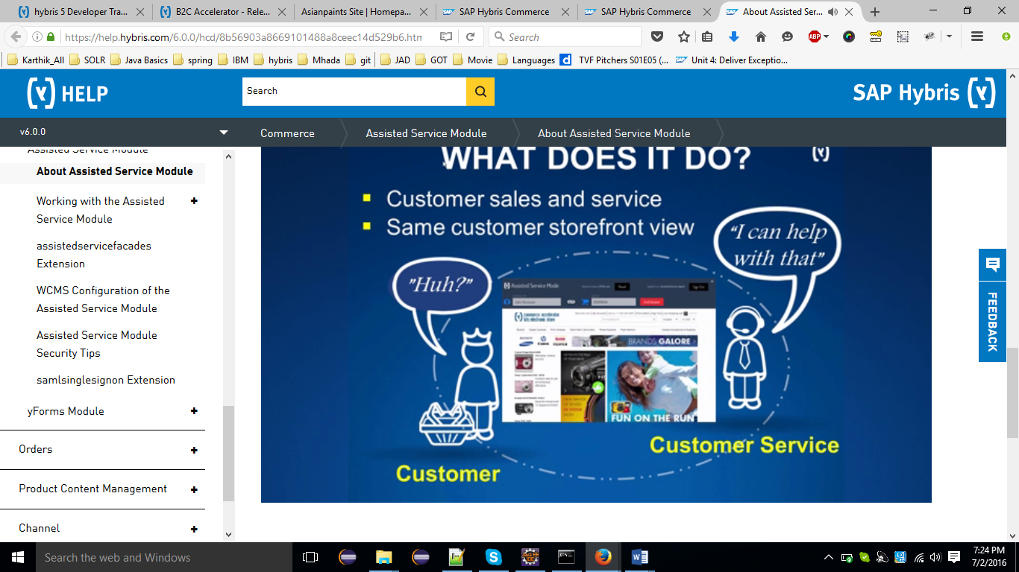

**Using the ASM, a customer sales and service person can:**

1. Find a customer’s account and session, or anonymous cart
2. Assign a customer to an anonymous cart (or vice versa)
3. Create a new customer account on the customer’s behalf
4. Provide service and support to a customer within their My Account area
5. Provide sales support within the product catalog, cart, and checkout flow, adding products to the cart and checking them out for the customer.

**Compatibility:**

1. The ASM is compatible with the SAP Hybris Commerce B2C Accelerator storefront, and is fully compatible with the responsive design of the storefront.
2. The Assisted Service Module is compatible with the Hybris Telco and B2B Accelerator storefronts.

## What are the advantages of ASM?

1. Extends self-service support
2. Reduces costs by applying special promotions which ASM employees can see.
3. Increased customer satisfaction and gains experience from service support.

## Why Does Your Company Need Assisted Service?

1. A growing number of complex bundles of products and services raises the need to support/help customers in their customer journey.
2. Sales and service support personnel need to provide real-time advice to their customers, guide them through the buying process and help with problems.

## **Install and Initialize the B2C Accelerator**

1. Go to installer directory
2. Run   
                  install.bat -r b2c_asm
3. Run initialization  
                 install.bat -r b2c_asm initialize
4. Run the server  
                 install.bat -r b2c_asm start   OR   ./install.sh -r b2c_asm start
5. Add to your hosts file the line 127.0.0.1   asianpaints.local
6. Navigate to <http://asianpaints.local:9001/asianpaintsstorefront/?site=asianpaints>

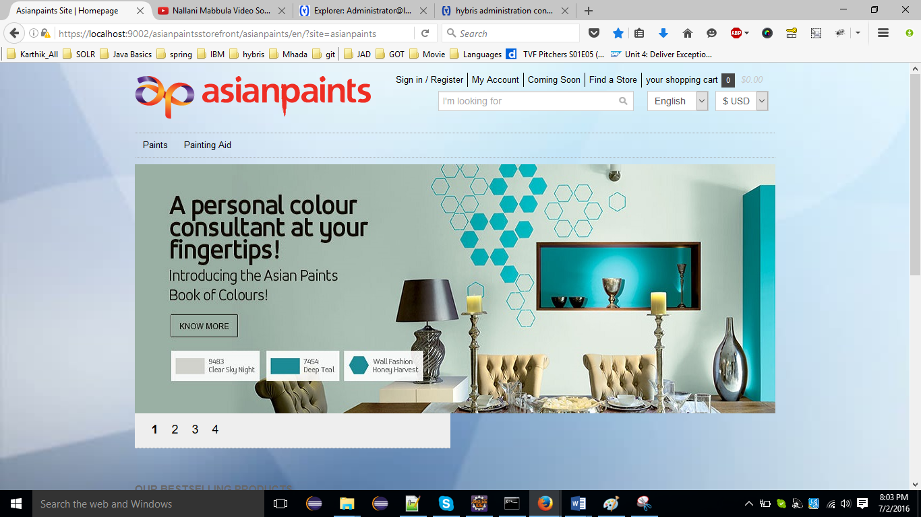

## Enabling ASM

1. Append **?asm=true** to the URL to enable the ASM mode <https://localhost:9002/asianpaintsstorefront/asianpaints/en/?asm=true>
2. The username will be "asagent" and the password will be **123456**
3. You should be logged in as ASM agent and be able to sign-out from the session by clicking **sign out** button

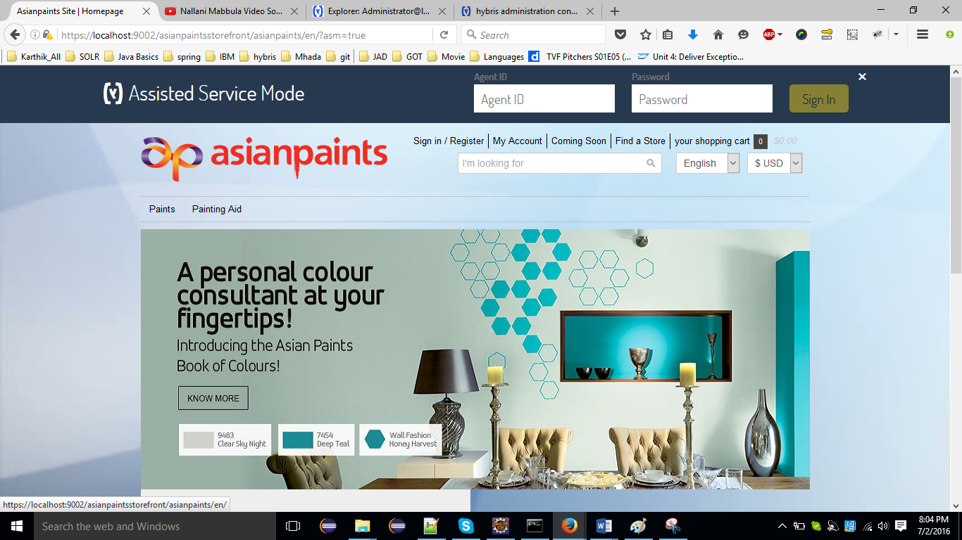

## Creating New Extension for custom restrictions

1. Make sure hybris server is stopped
2. Change to platform directory, set the Ant environment by opening the **setantenv.bat** file, and invoke the platform's **ant extgen task**. You will need to:
   1. Select yempty for the extension template
   2. Enter the name asmtrail for the extension.
   3. Enter the package prefix de.hybris.platform.asmtrail
3. The Ant script will now create a skeleton extension for you in YOURPATH/bin/custom/asmtrail but this is not yet imported into Eclipse.
4. Add this the new extension to config/localextensions.xml at the end of the file before extensions end tag

|  |
| --- |
| **config/localextensions.xml** |
| <extension name="asmtrail" /> |

1. Navigate to the newly created extension and edit the file **YOURPATH/bin/custom/asmtrail/extensioninfo.xml** and add the below line as the first line after extension tag.

|  |
| --- |
| **custom/asmtrail/extensioninfo.xml** |
| <requires-extension name="assistedservicefacades"/> |

1. Run the ant all command.
2. Import the generated extension into your Eclipse environment:
   1. Right-click in package explorer and select Import
   2. Select General|Existing Projects into Workspace and browse to the new extension YOURPATH/bin/custom/asmtrail
   3. Make sure that the Copy projects into workspace check box is not checked before clicking on the Finish button
   4. You should now see the extension in your Eclipse Package Explorer

## Summary

In this step you should have learned how to:

* Install B2C accelerator
* Install ASM addon
* Enable ASM mode and login as ASM agent
* Create new extension for further trail steps

## **Restricting URL Access to a Usergroup**

## Tasks

1. [New asmtrailstorefront extension](https://wiki.hybris.com/display/R5T/Restricting+URL+Access+to+a+Usergroup#RestrictingURLAccesstoaUsergroup-Newasmtrailstorefrontextension)
2. [Applying URL Restriction for Already Defined asagentsalesgroup](https://wiki.hybris.com/display/R5T/Restricting+URL+Access+to+a+Usergroup#RestrictingURLAccesstoaUsergroup-ApplyingURLRestrictionforAlreadyDefinedasagentsalesgroup)
3. [Creation and Applying a Custom URL Restriction](https://wiki.hybris.com/display/R5T/Restricting+URL+Access+to+a+Usergroup#RestrictingURLAccesstoaUsergroup-CreationandApplyingaCustomURLRestriction)

## New asmtrailstorefront extension

In this step we are going to create a new storefront extension for our trail to be able to put **assistedservicestorefront** as a dependency in it

1. Make sure hybris server is stopped
2. Change to platform directory, set the Ant environment by opening the setantenv.bat file, and invoke the platform's ant extgen task. You will need to:
   1. Select yempty for the extension template
   2. Enter the name asmtrailstorefront for the extension.
   3. Enter the package prefix de.hybris.platform.asmtrailstorefront
3. The Ant script will now create a skeleton extension for you in YOURPATH/bin/custom/asmtrailstorefront but this is not yet imported into Eclipse.
4. Add the new extension to config/localextensions.xml at the end of the file before extensions end tag.

|  |
| --- |
| **config/localextensions.xml** |
| <extension name="asmtrailstorefront" /> |

1. Navigate to the newly created extension and edit the file **YOURPATH/bin/custom/asmtrailstorefront/extensioninfo.xml** and add the below line as the first line after extension tag:

|  |
| --- |
| **config/asmtrailstorefront/extensioninfo.xml** |
| <requires-extension name="assistedservicestorefront"/>  <requires-extension name="asmtrail"/> |

1. Run the ant all command.
2. Import the generated extension into your Eclipse environment
   1. Right-click in package explorer and select Import
   2. Select General → Existing Projects into Workspace and browse to the new extension YOURPATH/bin/custom/asmtrailstorefront
   3. Make sure that the Copy projects into workspace checkbox is not checked before clicking on the Finish button.
   4. You should now see the extension in your Eclipse Package Explorer

## Applying URL Restriction for Already Defined asagentsalesgroup

1. In this step we will restrict storefront URL for access by Assisted Service Agent from asagentsalesgroup.
2. Let's for instance restirct access to update password page:
3. Navigate to /asmtrialstorefront/resources/asmtrialstorefront-spring.xml. Change its content to:

## 

1. Open storefront with launching ASM <https://asianpaints.local:9002/asianpaintsstorefront/asianpaints/en/?asm=true>
2. Login as an agent from **asagentsalesgroup** - by default it's **asagentsales** / **123456**
3. Navigate to **/my-account** page and try to update password
4. Error message will be shown

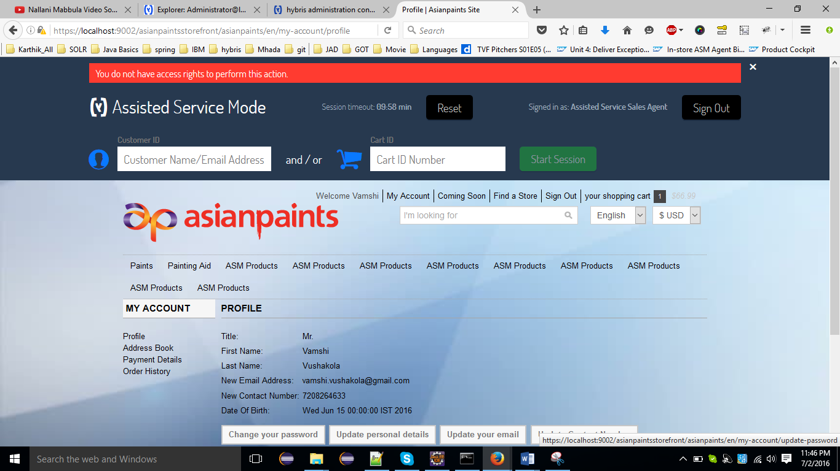

## Creation and Applying a Custom URL Restriction

1. Add new agent and group via Impex:
   1. create folder /asmtrialstorefront/resources/asmtrialstorefront/import/common
   2. create file user-groups.impex in it with a following content:

|  |
| --- |
| /asmtrailstorefront/import/common /user-groups.impex |
|  |

* 1. Stop the server and call **ant initialize**

1. change /asmtrialstorefront/resources/asmtrialstorefront-spring.xml

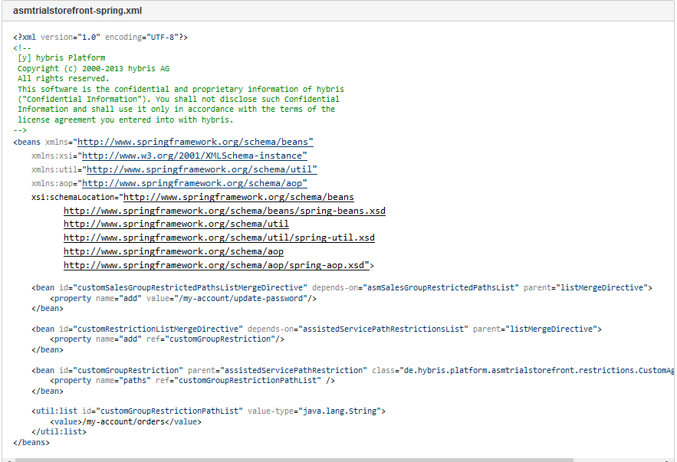

1. implement your custom restriction class:

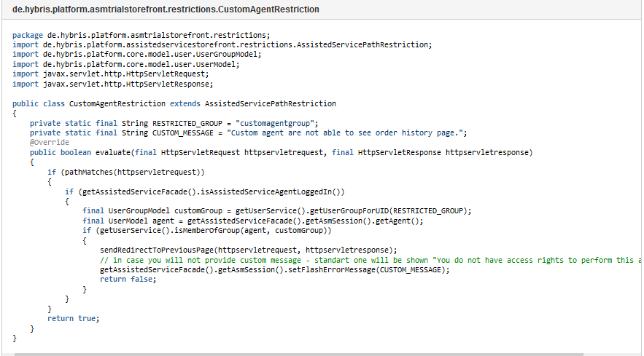

1. run the server
2. start ASM, login as customagent / 123456 and start emulation for any customer
3. Try to reach My Account -> Order History page
4. Error message will be shown

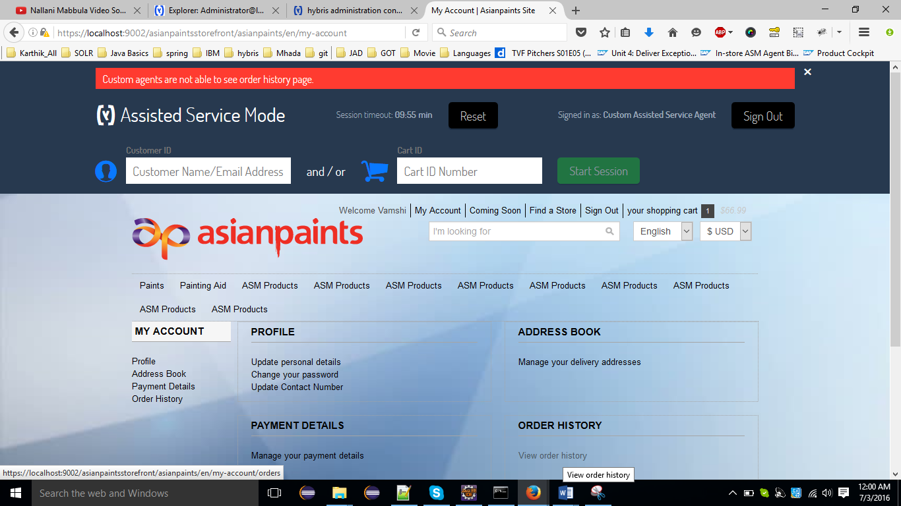

## Summary

In this step you have learned how to:

* Create a URL restriction for already existed asagentsalesgroup
* Create a custom URL restriction for custom newly created agent group

## **Promotion restrictions**

This will provide information needed to create a promotion restriction that is only valid for ASM agent.

## Tasks

* [Review  and update items.xml](https://wiki.hybris.com/display/R5T/Promotion+restrictions#Promotionrestrictions-Reviewandupdateitems.xml)
* [Review and deploy the promotion restriction java file](https://wiki.hybris.com/display/R5T/Promotion+restrictions#Promotionrestrictions-Reviewanddeploythepromotionrestrictionjavafile)
* [Updating the system](https://wiki.hybris.com/display/R5T/Promotion+restrictions#Promotionrestrictions-Updatingthesystem)
* [Define promotion in hmc](https://wiki.hybris.com/display/R5T/Promotion+restrictions#Promotionrestrictions-Definepromotioninhmc)
* [Test the promotion restriction with the ASM](https://wiki.hybris.com/display/R5T/Promotion+restrictions#Promotionrestrictions-TestthepromotionrestrictionwiththeASM)

1. Update asmtrail-items.xml file in asmtrail project to contain the information which are responsible for creating promotion restriction that we will use later in the hmc to restrict promotions for ASM agent only

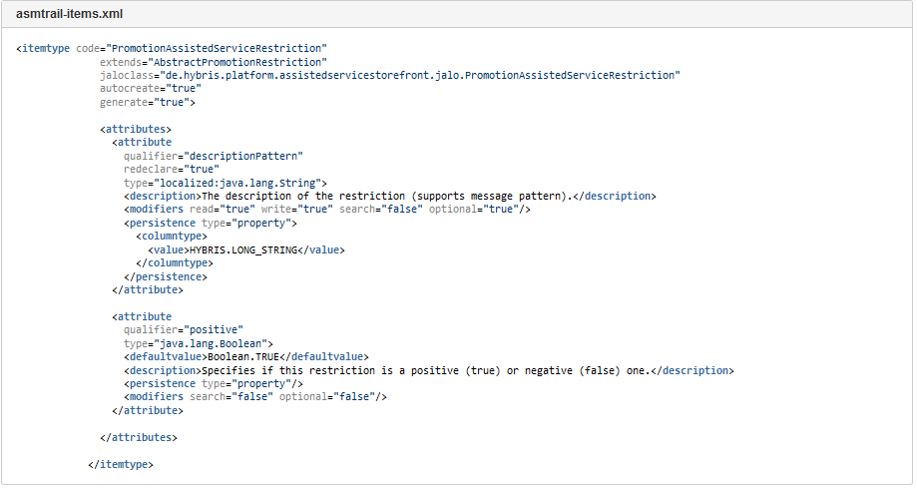

1. Run "**ant all**" from the command prompt, this will create the "GeneratedPromotionAssistedServiceRestriction" as well as "PromotionAssistedServiceRestriction" classes which will be used in next step
2. There will be a compilation error from the previous command which will be fixed in the below step

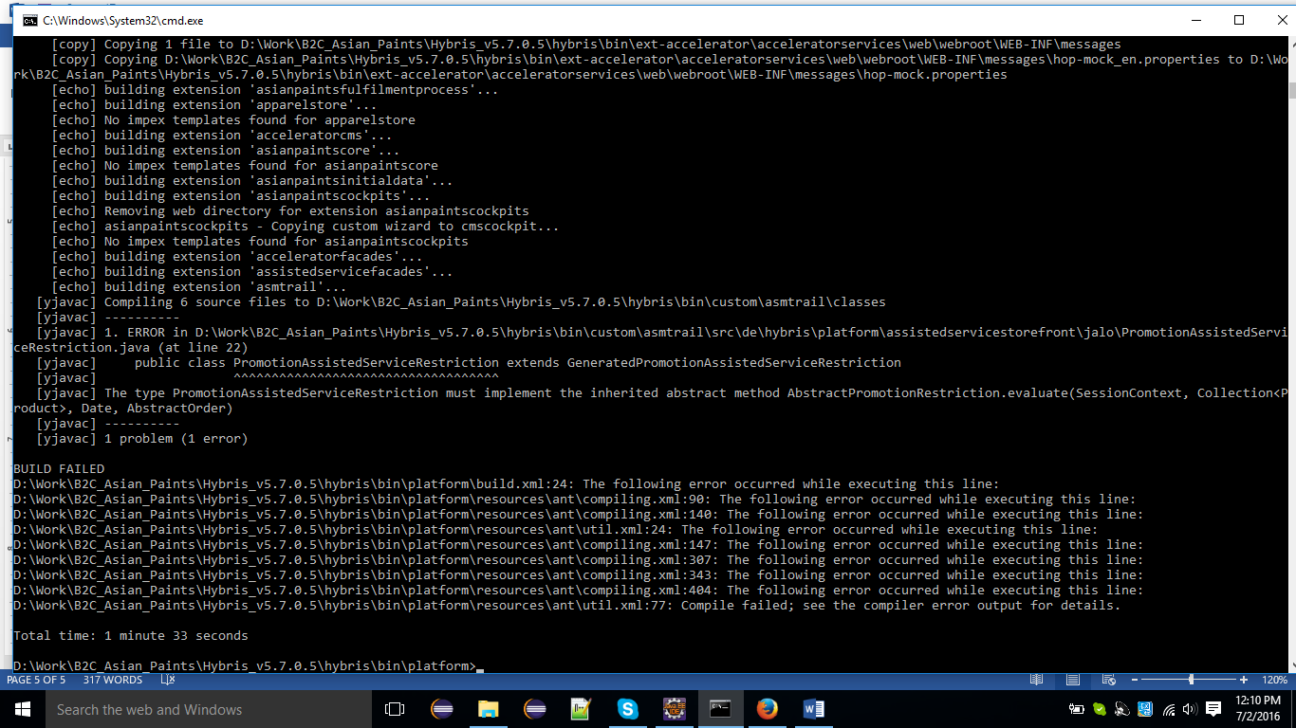

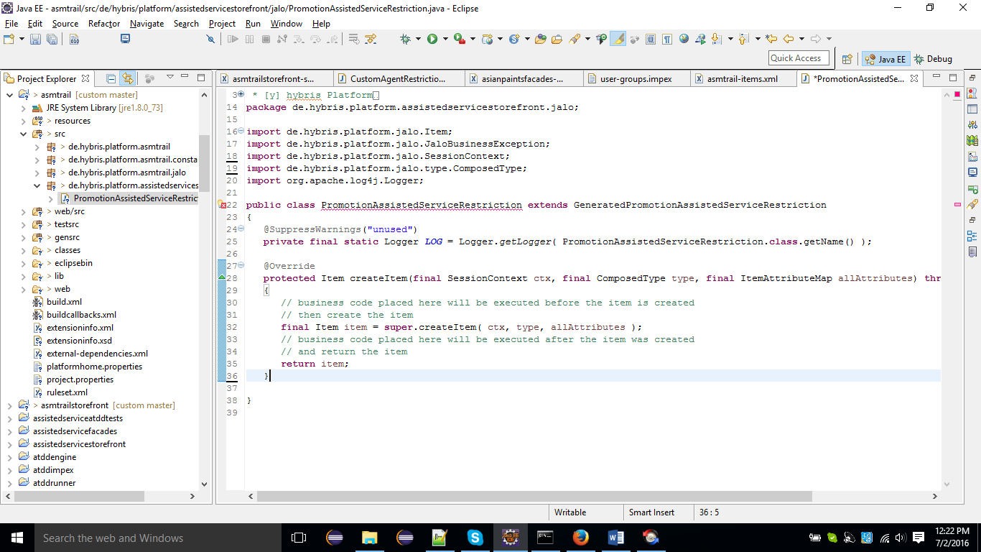

## To resolve the error

## Review and deploy the promotion restriction java file

1. Copy the code below and place it in PromotionAssistedServiceRestriction class in asmtrail project and place the new class in this package: de.hybris.platform.assistedservicestorefront.jalo

|  |
| --- |
| /asmtrail/src/de/hybris/platform/assistedservicestorefront/jalo/PromotionAssistedServiceRestriction.java |
|  |

1. After placing the class try to refresh the project and call "ant all" from the command prompt again.

## Updating the system

* In order for the effects to take place we will need to update the system, follow the below steps to do so:
  + Start hybris server with hybrisserver.bat or hybrisserver.sh
  + Navigate to <http://asianpaints.local:9001/> and login as admin
  + Go to **Platform** tab and then select **Update**
  + Uncheck all the check boxes except for "**Update running system**"
  + Make sure you select "**asmtrail**" module and check it as well
  + Click the update button and wait till the update is done.

## Define promotion in hmc

In order to create restriction and apply it to ASM agent follow the below steps:

* Navigate to hybris management console (hmc) and login
* Expand **Marketing**-> **Promotions**

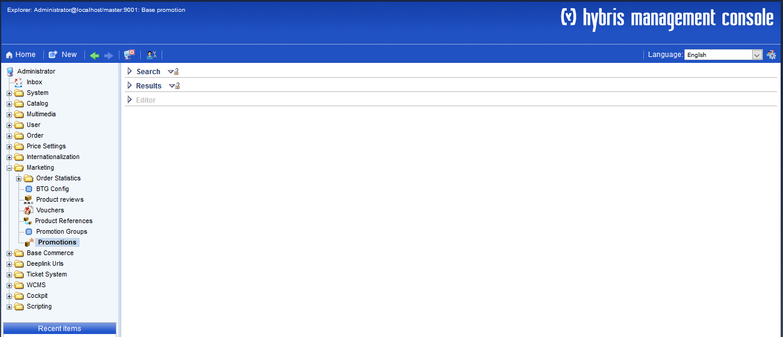

Right click on the **Promotions**node and select Create -> Percentage Discount

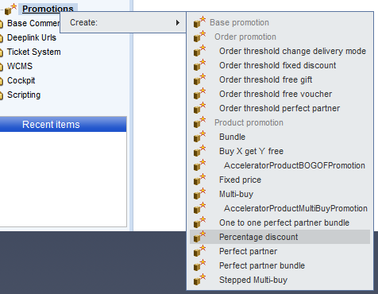

After creating the new promotion fill the information as shown below:

* Fill in the Identifier value: ASMDiscount
* Title would be: Special 10% discount for ASM
* Promotion Group: asianpaintsPromoGrp
* Description would be: Special 10% discount that a customer service agent can offer to a customer being supported using the ASM!
* Make sure to check  the **Enabled** check box
* You can put any value in the Priority field let's say 400
* Make sure to have a category selected in the qualifying products section, in this trail we will make the promotion valid for any product in categorized as Open Catalogue (online catalog version)

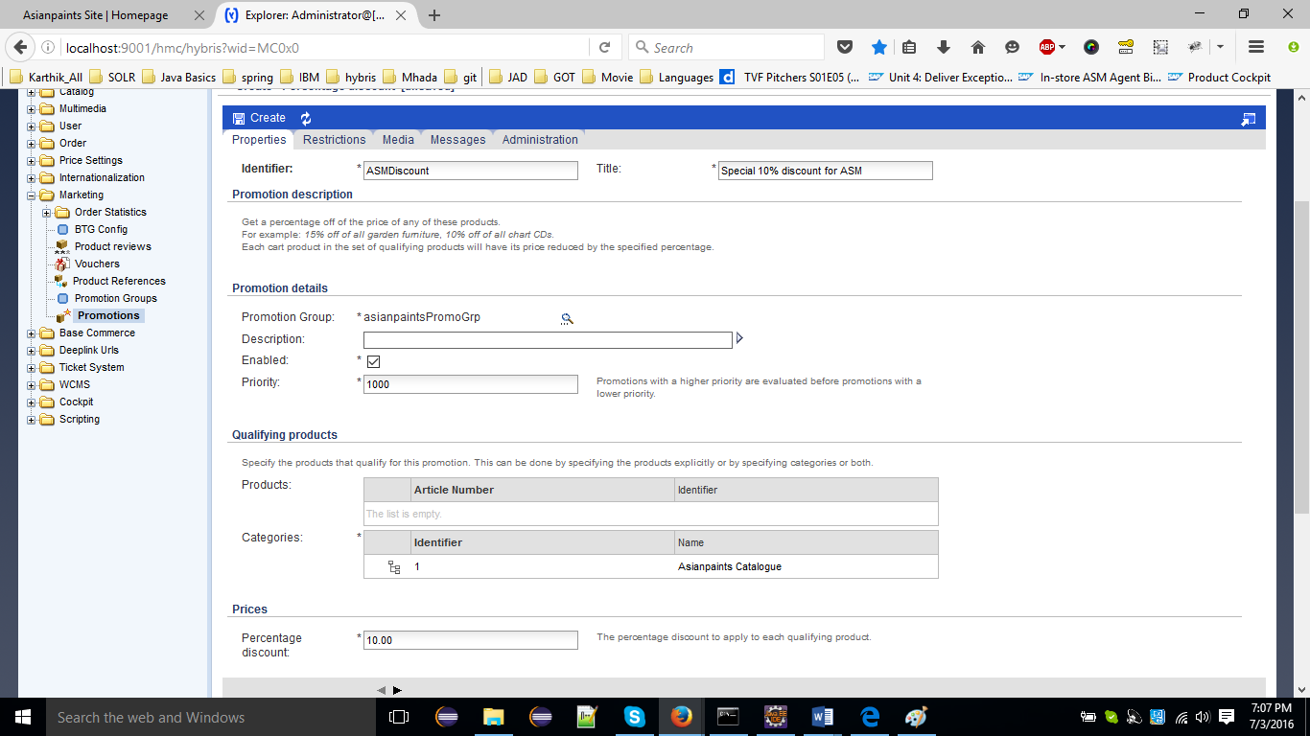

Select PromotionAssistedServiceRestriction from the restrictions types

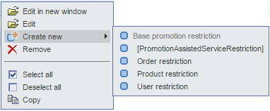

Go to Messages tab and fill the fired message field with: Special {0} discount given to you from our customer service agent when we supported you using our Assisted Service Module - this saved you {2}!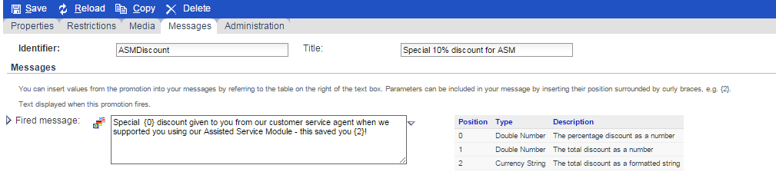

## Test the promotion restriction with the ASM

To see promotion restriction in action you will have to follow the below steps:

* Navigate to <http://asianpaints.local:9001/asianpaintsstorefront/asianpaints/en/?asm=true>
* Login with ASM credentials asagent/123456
* Add any product to cart and checkout it out
* You will find that promotion is applied on all items in the cart, to be eligible for the promotion the ASM will have to do the checkout process till the end and logging out in any step before completing checkout flow will result in losing the promotion

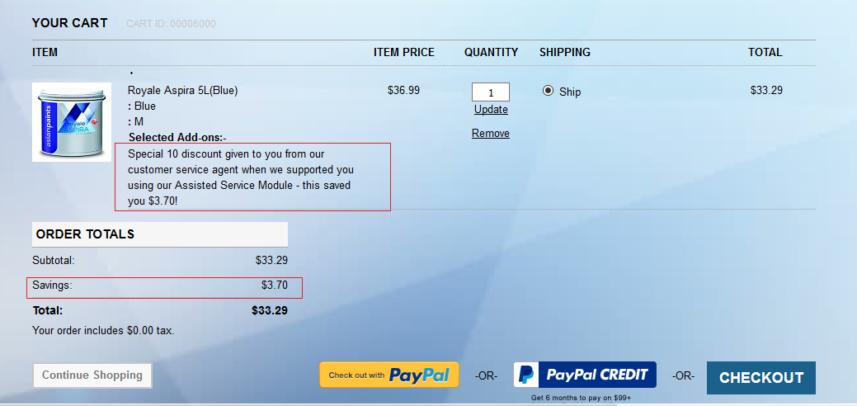

If ASM agent logged out the item will be still available in cart but the promotion will be no longer applied.

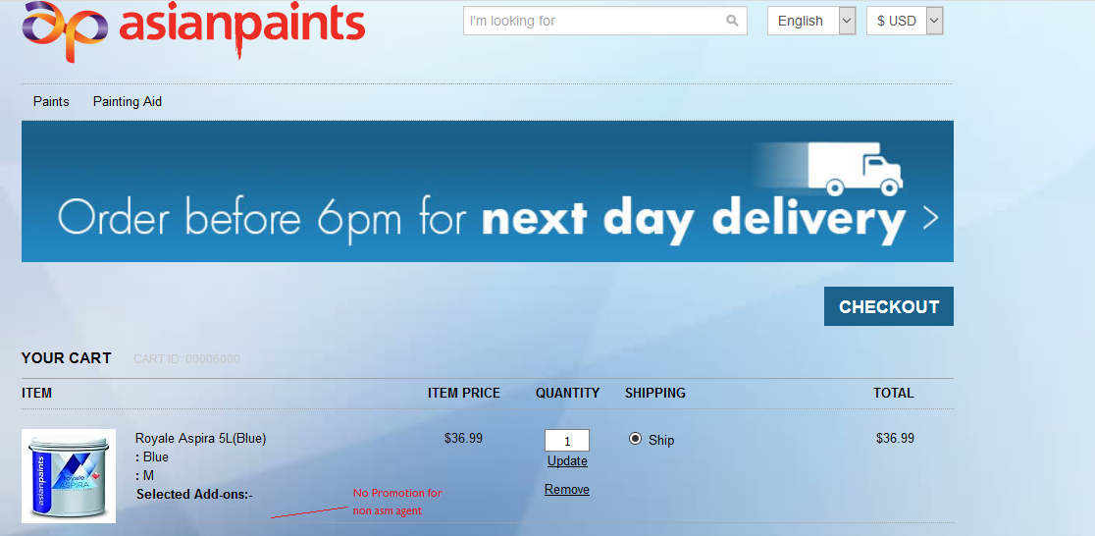

## Summary

In this step you should have learned:

* How to create promotion restriction and configuring it through XML
* How to configure promotion restriction in hmc and enable it only for ASM agent

## **Category / link display restriction**

This will create category for ASM agent and associate it to some products so they can see by the ASM from the ASM menu link.

## Tasks

* [Define ASM Category and link through impex](https://wiki.hybris.com/pages/viewpage.action?pageId=291335151#Category/linkdisplayrestriction-DefineASMCategoryandlinkthroughimpex)
* [Applying restriction on ASM link from CMS](https://wiki.hybris.com/pages/viewpage.action?pageId=291335151#Category/linkdisplayrestriction-ApplyingrestrictiononASMlinkfromCMS)
* [Associating products to ASM Category](https://wiki.hybris.com/pages/viewpage.action?pageId=291335151#Category/linkdisplayrestriction-AssociatingproductstoASMCategory)
* [Test the category and link display restriction with the ASM](https://wiki.hybris.com/pages/viewpage.action?pageId=291335151#Category/linkdisplayrestriction-TestthecategoryandlinkdisplayrestrictionwiththeASM)

## Define ASM Category and link through impex

1. In order to define a new category only valid for the ASM user we will have to follow the below steps:
2. Navigate to hybris admin console [http://localhost:9001/console](http://localhost:9001/console/impex/import)
3. Go to Impex import tab under the "Console" tab
4. Point to the location of impex file: [projectdata_content.impex](https://wiki.hybris.com/download/attachments/291335151/projectdata_content.impex?version=1&modificationDate=1446115655000&api=v2)
5. The impex file is just creating a category with the below information:
6. Category name : ASM Category
7. Category Id : 1500
8. Category super category : 1 (which is Open Catalog)
9. The impex is also creating a navigation link that will be shown in the storefront, later we will know how to restrict it only to be visible to ASM agent only, the link is created with the below information :
10. Link name: ASM Products
11. Link will appear at the top hand side of the page
12. When clicking on the link it will display the products that have been associated with "ASM Category" category

|  |
| --- |
| **cms-content_en.impex** |
|  |

1. Make sure to synchronize the electronics site after doing the import from the cms cockpit
2. Before ASM Login there is no ASM Product Category

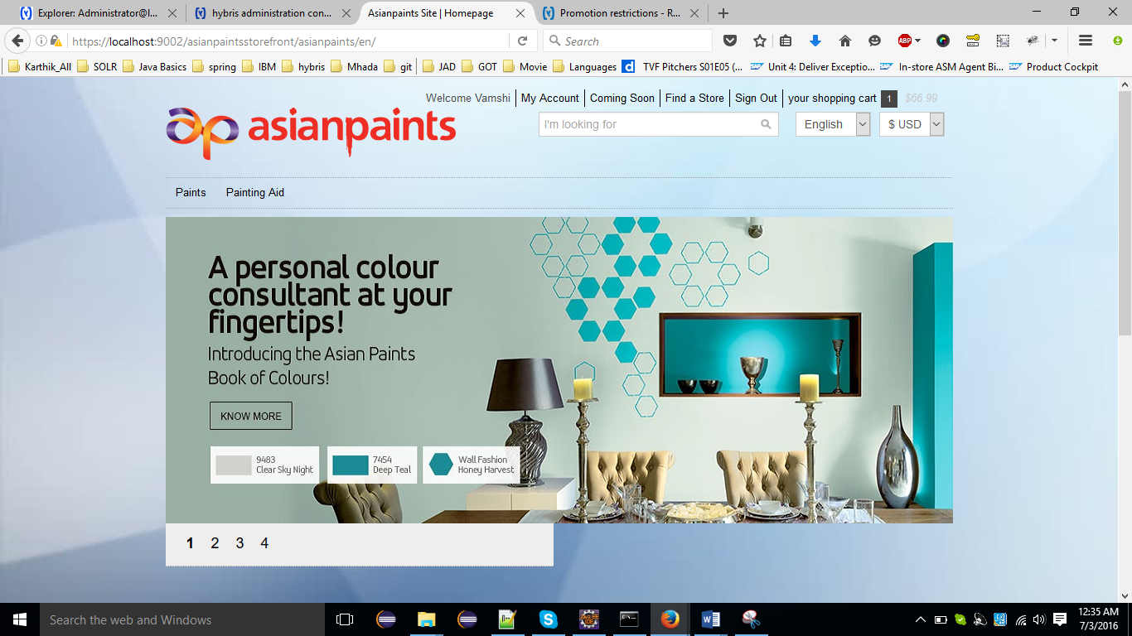

1. After ASM login

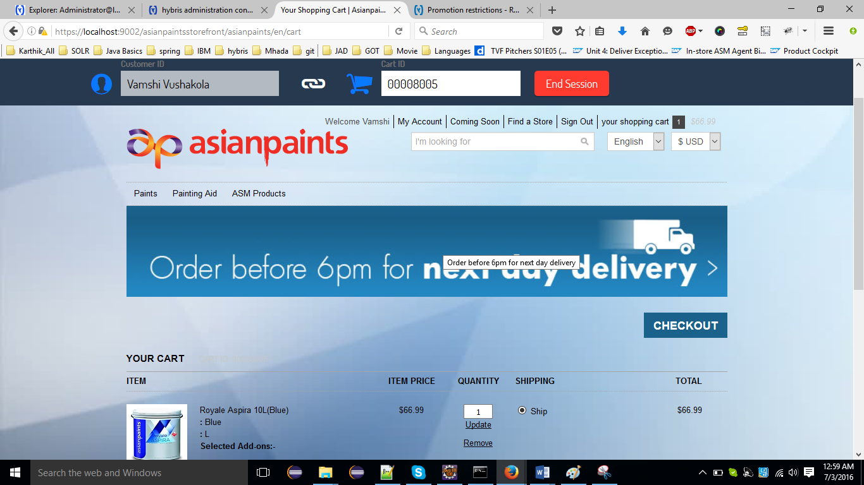

## Applying restriction on ASM link from CMS

1. In order to make the link we added in the previous step only visible to the ASM agent we will need to add a restriction on this link, this can be done from CMS Cockpit as show below:
2. Navigate to <http://asianpaints.local:9001/cmscockpit>
3. Login and then switch to "Navigation" perspective
4. Expand Electronics site in "Websites" section
5. Navigate to ASM Category through SiteRootNode -> Asianpaints Site -> ASM Category
6. Edit ASM Category

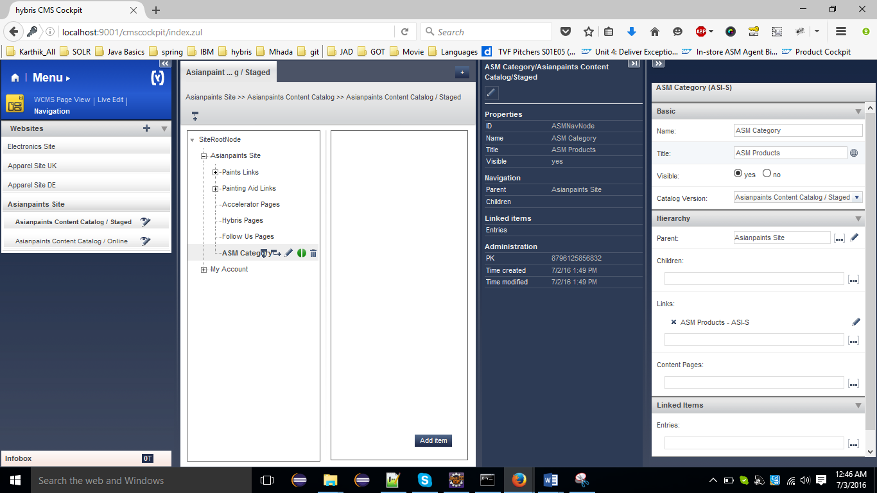

In the editor area, link section click on the "ASM Products" to edit the link component

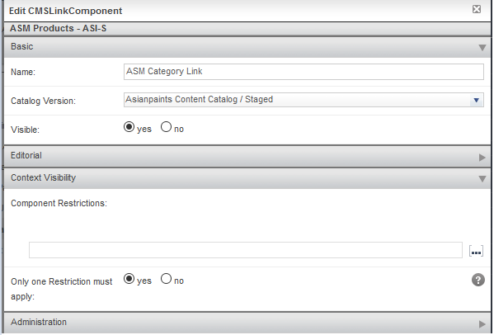

Expand the Context Visibility section and create new component restriction by selecting "AssistedServiceSessionRestriction" restriction, for the restriction name and Id enter: ASM Restriction

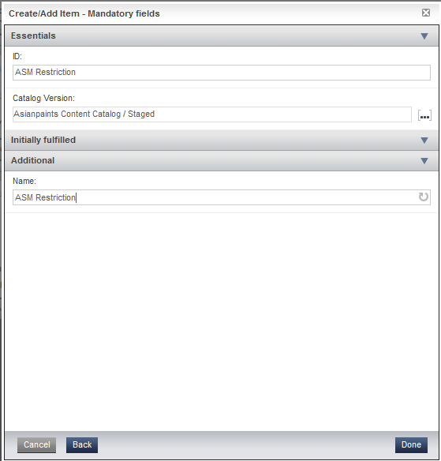

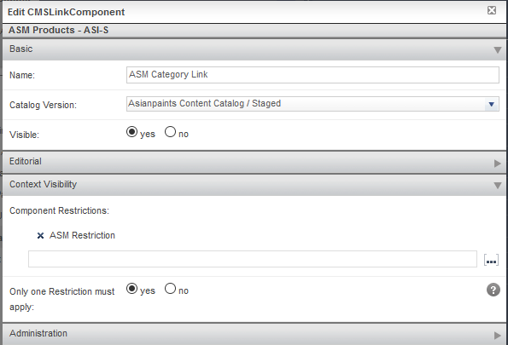

## Associating products to ASM Category

In this step we will associate a product with ASM Category so that it would be visible when the ASM agent navigates to the ASM category page, to do so we will have to follow the below steps:

* Navigate to Product Cockpit <http://asianpaints.local:9001/productcockpit>
* Login as the product manager and navigate to Asianpaints Product Catalog Staged
* Search for product with name "Cyber-shot W55" (Feel free to add some more products to ASM Category)
* Edit this product and expand the "Category System" section
* In the Category System try searching ASM Category which we created in previous step, once you find it click and add it as a category for this product
* Synchronize the product so it is reflected in the online catalog

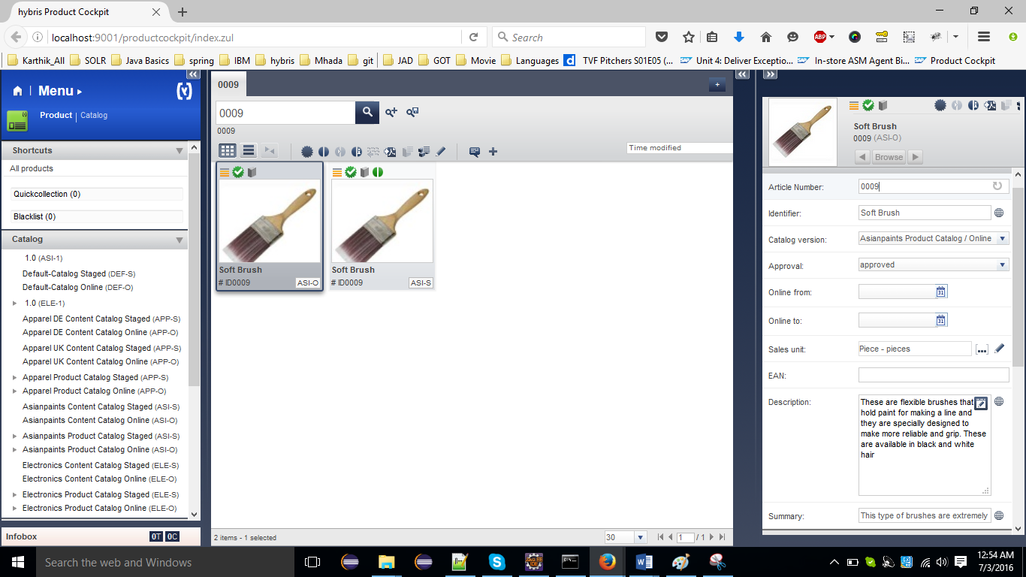

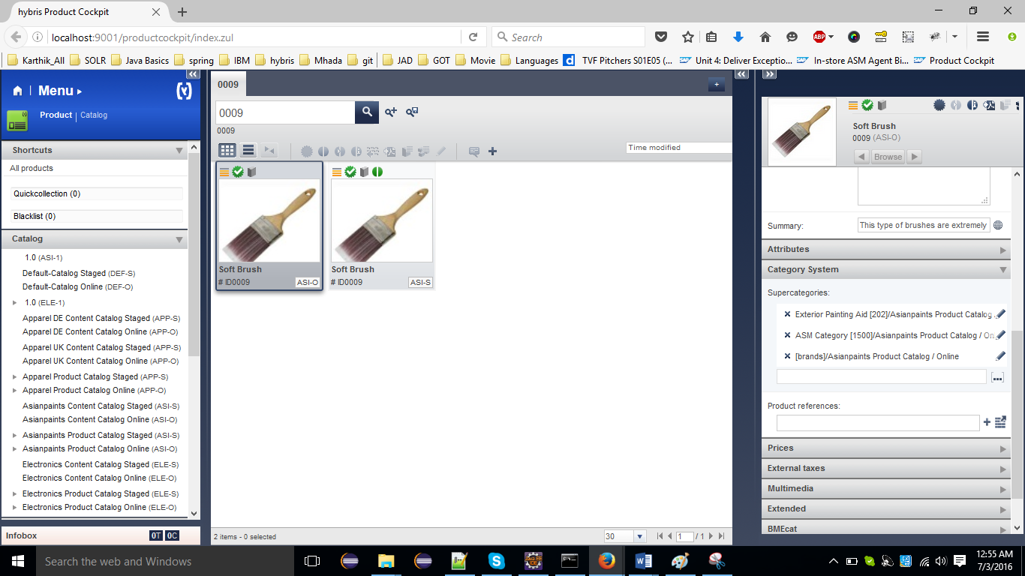

## Test the category and link display restriction with the ASM

In order to make sure that this link and the category are visible only to ASM we will have to follow the below steps:

* Navigate to <http://asianpaints.local:9001/asianpaintsstorefront/asianpaints/en/?asm=true> and login as ASM agent (asagent/123456)
* Once you logged in you will be able to see "ASM Products" link on the right of the menu

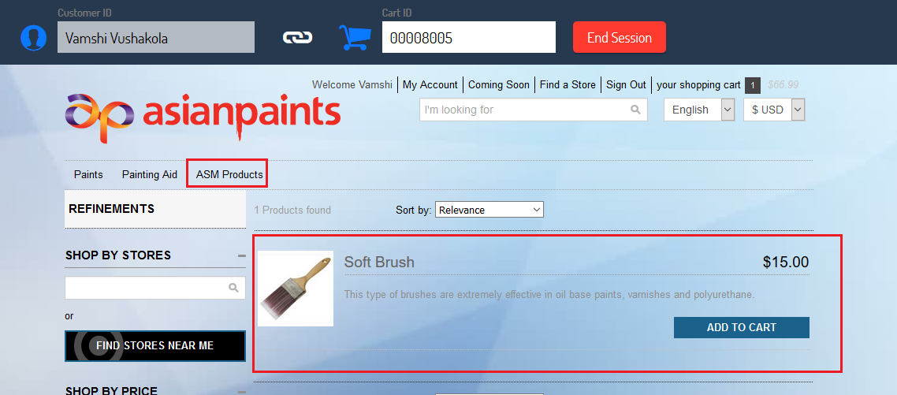

* Now sign out from ASM, you will not be able to see the "ASM Products" link anymore and you will not be able to search for any product categorized as ASM Category

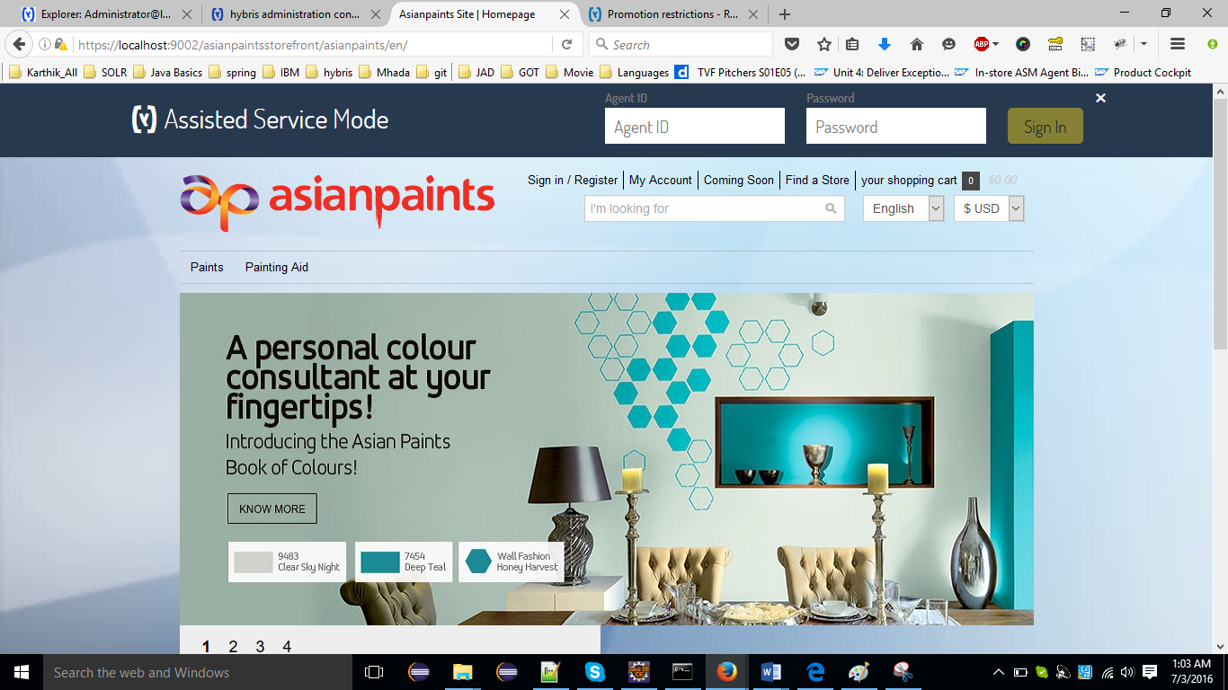

## Summary

In this step you should have learned:

* How to create a category and link
* How to restrict a category and link to ASM

## **Working with the Assisted Service Module**

1. When an ASM agent logged in to ASM, timer starts for security reasons. Which is configured for 10mins. We can change this time as our requirement from properties file.
2. Now ASM agent requires some information from customer side which may be Customer Name or Cart ID Number to proceed further.
3. So customer can give Customer Id or Cart ID Number to ASM agent.

## Two Different cases an ASM agent can get an information from customer

## In-store ASM Agent Binds a Customer's Account to an Anonymous Cart

The Assisted Service Module is used by customer service representatives to help customers with their storefront experience. This section focuses on presenting the main functionality of the Assisted Service Module.

Here we have a small situation

**Frank – ASM agent**

Frank is an ASM agent who is available to physically help a customer with their storefront browsing, purchasing and administration.

**Carl – Customer**

Carl is a customer that may be visiting a retail store, be at home in their domestic environment, or a business person in their office / workplace.

1. Frank is approached by Carl who has already added the items he wants to purchase to his cart, but has forgotten to login beforehand, requesting support.
2. As there are many different items in the cart, logging in and adding them manually again is out of the question, as Carl is in a hurry. In order to help Carl, Frank performs the following steps:
   1. On his personal computer, Frank logs in to the Assisted Service Module by adding the ?asm=true string to the storefront URL visible in the address bar. This launches the ASM panel.
   2. In the ASM panel, Frank logs in using his asagent credentials.

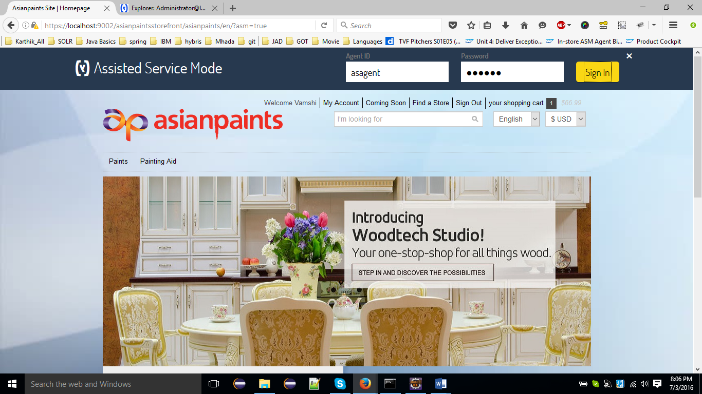

1. Frank asks Carl for the Cart ID. Carl finds the Cart ID on the cart page and tells Frank what the Cart ID is.
2. On his personal computer, Franks logs into the ASM and types Carl's Cart ID into the Cart ID field and clicks the Start Session button. Frank is now emulating Carl's cart.

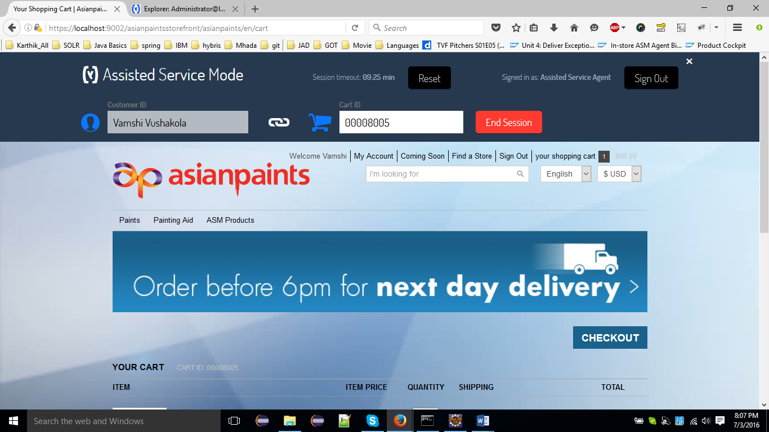

1. Frank asks Carl for his account name, and enters this into the **Customer ID** input field. Once Frank has typed in the third character of Carl's account name, the **Customer ID** input field displays a list of users, helping Frank to find the user he is looking for (note that an email address, account creation date and the last 4-digits of Carl's credit card are displayed so that Frank can confirm that he is finding the correct customer account. Frank clicks Carl's entry on the list to select his account.

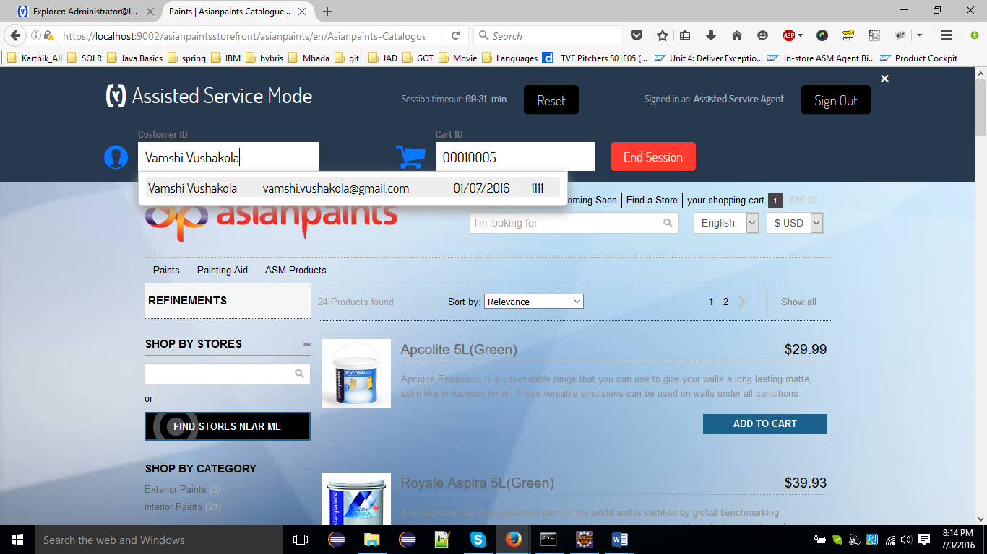

1. Carl's first name and surname are populated to the **Customer ID** input field. Frank clicks the **Assign** button.

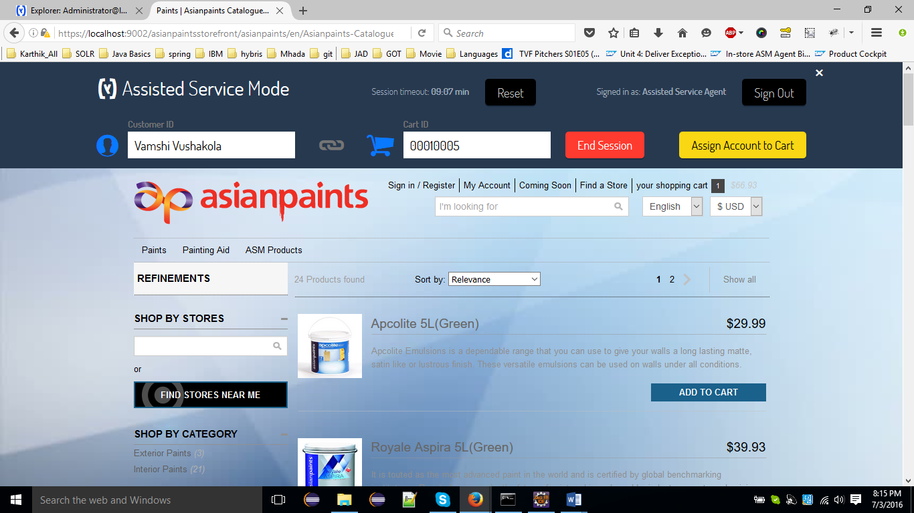

Note

There are several cart restrictions present in the Assisted Service Module:

* A customer can only have one cart.
* If a customer has a cart already, assigning an anonymous cart overrides the previous cart.
* There is no possibility of binding a cart to an account if the cart is already bound to an account.

1. Carl's account has been bound to the cart. Frank clicks the **x** button to sign out and close the ASM. Carl can now see that the items he added to the anonymous cart before logging in are now bound to his account.

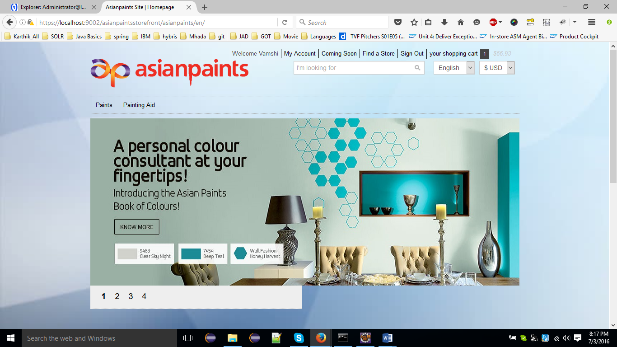

## Remote ASM Agent Creates an Account for an Online Customer

The Assisted Service Module is used by customer service representatives to help customers with their storefront experience. Here you can find more use cases.

**Situation Note**

This user story is valid for on-line environment, where an ASM Agent is not physically present with a customer.

Here we have a small situation

***Ashley - ASM Agent***

Ashley is an ASM agent who may be working in a call center assisting customers with storefront browsing, purchasing and administration.

***John – Customer***

John is an online customer that may be browsing through the storefront at home in their domestic environment.

1. John is trying to buy his grandson a birthday present, but he's not that technologically savvy and the online store keeps asking him for all kinds of information. John decides to call customer support in order to have someone help him. Over the phone, John describes his current situation to Ashley, who decides to help John create a new user account.
2. Ashley logs in to the ASM by adding ?asm=true to the address bar, entering his credentials and clicking the Sign In button.
3. Ashley asks John for name, surname, and e-mail address in order to create John's account. Ashley types the information in the **Customer ID** input field, separated by a comma.

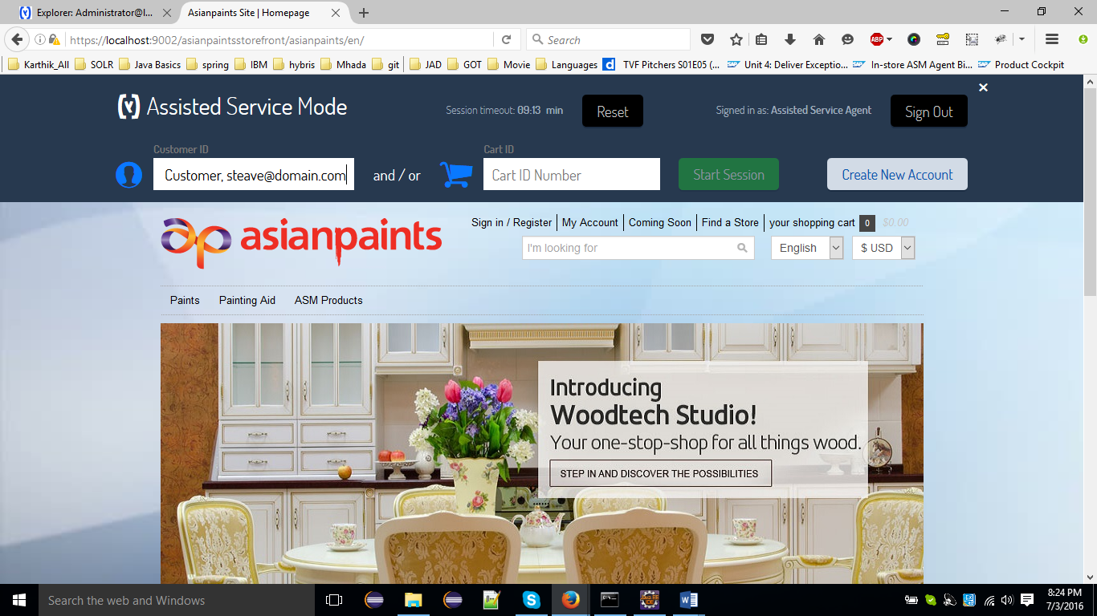

1. Ashley clicks the **Create** button. The system redirects Ashley to the Account Homepage and a registration e-mail is sent to the John's e-mail address.

**Note:** The ASM expects customer data in the following format: **Name Surname, email@domain**.If the data you type into the **Customer ID** input field does not match the expected pattern, the **Create** button is not enabled.

1. John's default currency and language are set relative to the session's currency and language. Ashley can now create a new payment method, add a new delivery address, or perform the entire checkout process on John's behalf.

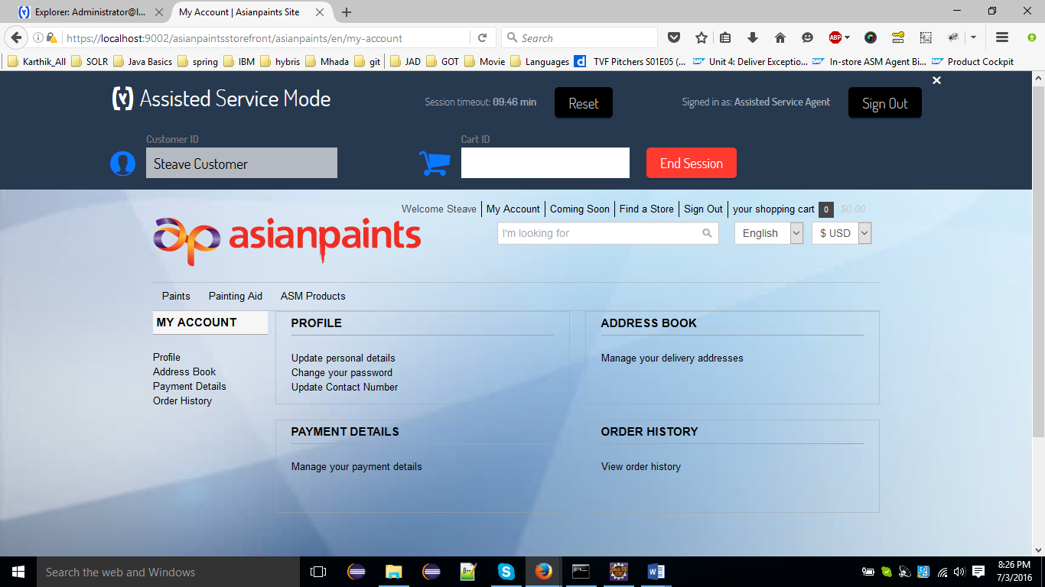

1. Ashley finishes emulating John's account by clicking the **End Session** button.
2. Now Ashley instructs John to open the storefront once again and select the **Forgotten your password?** Option. John follows Ashley's advice, types in his e-mail address where required, and receives his storefront password via e-mail. John can now log into the storefront and purchase a gift for his grandson.

**Note:** The new customer account is created **without** a password. If the customer wants to log into the storefront later, they have to request a new password using the **Forgotten your password?** Link on the storefront.